

**Biomedical Engineering Lab – ECG & HS**

Conducted by Hila C. & Ilay P.  
Group #104  
Experiment date: 17.10.2021

1. Introduction____________________

The heart’s function is to pump blood throughout our body, and transport oxygen and nutrients using our blood. To do so, the heart is generating an electrical signal, dictating the rhythm of its beating. The electrical signal is generated in the sinoatrial node (SA node), then being spread to the atrial fibers and internodal pathways, which causes atrial depolarization. From there, the signal continues to the atrioventricular node (AV node), bundle of Hiss, left bundle branch (LBB) and right bundle branch (RBB), ending in the Purkinje fibers. This path results in ventricular depolarization [1].

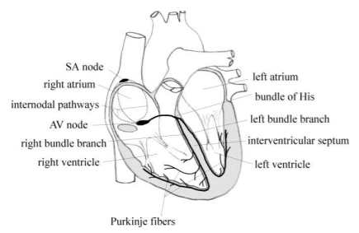

**Figure 1.** The heart and its electric parts.

A voltage difference is derived by the movement of electrical signal, which can be measured and viewed as a graph, named the Electrocardiogram (ECG).

Different waves and segments can be observed in the ECG, representing different stages of the heart’s function: P wave represents atrial depolarization, QRS complex represents ventricular depolarization, and T wave represents the ventricular repolarization. subsequently, P-R segment represents the time of impulse conduction from the AV node to the ventricles, S-T segment represents early ventricular repolarization, and finally, the T-P segment represents the time passed from ventricular repolarization the next atrial depolarization [1].

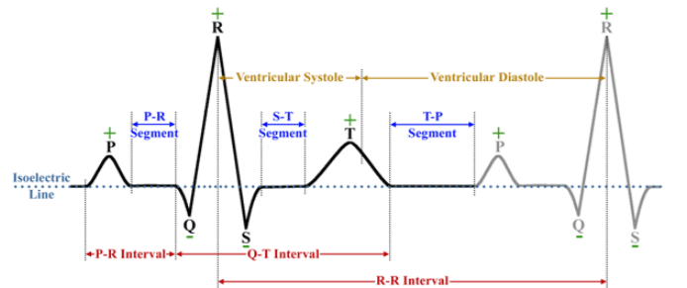

**Figure 2.** ECG’s waves, intervals, and segments.

The standard range for the QRS complex is 8-50 Hz, while standard ECG machines have a frequency range of 0.05-100 Hz [2], so higher frequencies can be shown in the ECG signal, acting as noise. In order to identify all the ECG components correctly, measurement must be sampled at a sampling rate of at least twice the maximum signal frequency, 200 Hz, based on Nyquist sampling frequency law. Sampling at this frequency allows to reproduce the original signal from the sampled one without the formation of the aliasing phenomenon: a phenomenon that occurs when a signal is sampled at a rate lower than the Nyquist frequency, expressed in an overlap between samples.

There are optional noises for ECG signal [3]:

* **Baseline wander** – a low frequency artefact where the x axis of the isoelectric line changes its base location. Mostly appears in frequencies lower than 0.5 Hz, and can result from breathing, movement, or incorrect electrodes attachment. One of the approaches to remove baseline wander is using high-frequency filter (HPF).
* **Excessive EMG** – mostly appears in high frequencies, resulting from the subject movement and expressing in amplitude changes or baseline wander. The phenomenon can be removed by low-pass filter (LPF).
* **Channel noise (additive white Gaussian noise)** – caused when being transmitted through a poor conditions channel.
* **Power-line interference** – PLI content intermix with the ECG signal, resulting in P-wave distortions. Caused by inductive and capacitive coupling of power lines during the ECG signal acquisition.
* **Miscellaneous noises (composite/random/electrode motion artefacts/instrumentation noises)** – refers to a mixture of various noises.

Random noise is added to the ECG signal to consider the worst-case scenario.

EM is caused by changes in the electrode-skin impedance with electrode motion

The heart’s cycle can be divided into two phases: systole and diastole. During systole, the ventricles contract, closing the atrioventricular valves- the mitral and tricuspid valves, and opening the semilunar valves- the aortic and pulmonary valves, resulting in blood shooting to the pulmonary artery and aorta in high pressure. During diastole the semilunar valves close, and the atrioventricular valves open, so the heart can be refiled with blood, preparing to the next systole [4].

There are four distinct heart sounds, marked as S1, S2, S3 and S4. S1 can be heard when the atrioventricular valves close, while S2 can be heard when the semilunar valves close, thus distinguishing between systole and diastole. While S1 and S2 are loud and can be heard easily using a stethoscope, S3 and S4 are very faint sounds and can hardly be heard. S3 occurs mostly when the ventricles are filled rapidly at the start of the diastole, and S4 occurs when the atrium contracts and injects blood to a non-compliant ventricle [4].

To compare with the ECG graph, S1 can be heard right after the appearance of the R wave, and marks the start of the ventricular systole, while S2 can be heard right after the T wave, marking the start of the ventricular diastole. If S3 and S4 are detectable, they can be heard in late (S3) and early (S4) ventricular diastole [4].

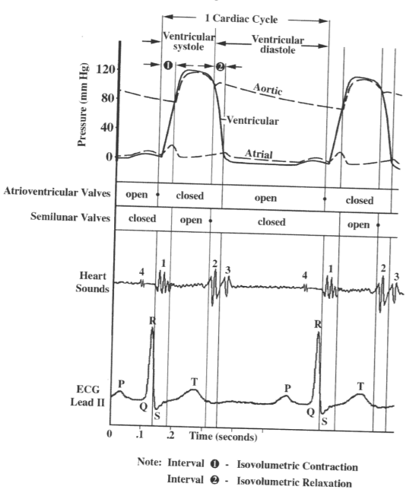

**Figure 3.** Events of the Cardiac cycle.

2. Experiment Objectives____________

1. Understanding the basics of ECG and recording it in three different positions:

* While calm and sitting.
* While calm and standing.
* Taking deep breaths while standing.

1. Confirming Einthoven’s law.
2. Detecting R wave peaks in the ECG recording and using the R-R intervals to compute the patient’s heart rate (HR) and its variability (heart rate variability- HRV), while also computing sound to noise ratio (SNR).
3. Detecting the main heart sounds (S1 and S2).
4. 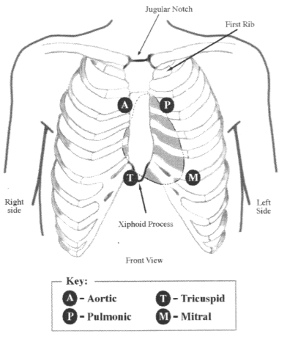Using Bioengineering oriented and common signal processing methods and algorithms in computing and confirming the Experiment’s objectives.

3. Methods and Materials___________

3.1 The experiment’s protocol:

3.1.1 General:

Recordings are taken using the BIOPAC device and software. Two types of cables are used in the experiment: lead and stethoscope cable. The lead cable has three electrodes: anode (negative, white), cathode (positive, red) and ground(black) electrodes.

Before any part of the experiment, the device is calibrated while the subject is attached to the relevant cables/electrodes, sitting still and calm.

3.1.2 Part A: ECG recording in different positions

Lead electrodes are attached to the subject to create lead I (anode- right arm, cathode- left arm, ground- right leg) and lead III (anode- left arm, cathode- left leg, ground- right leg), as shown in the experiment’s briefing. Recording is taken in three different positions: while sitting and calm (30 sec), while standing and calm (10 sec), and breathing heavily while standing (10 sec).

3.1.3 Part B: HRV & SNR

The same leads are attached to the subject as in Part A. The subject is then requested to sit still, and breath calmly, while a 60 seconds recording is taken.

3.1.4 Part C: Heart Sounds

Using the stethoscope, an optimal stethoscope diaphragm attachment spot is detected [1], to be able to record S1 and S2 properly. Lead II (anode- right arm, cathode-left leg, ground- right leg) is also attached to the subject. The subject is then requested to sit still and breath calmly, while a 20 seconds recording is being taken. Afterwards, the subject is requested to jump in place for 30-60 seconds, and then to sit still, while a 10 seconds recording is being taken.

**Figure 4.** Stethoscope positions for optimal detection of heart valve’s function.

3.2 Subject’s Profile:

The subject is a 24-year-old female, 1.54 meters tall and weighing 47 kilograms, practicing sports regularly.

3.3 Sample Rate computing:

Sample Rate of the BIOPAC was not a given. Therefore, sample rate was computed using:

3.4 Einthoven’s law:

Einthoven’s law states that the sum of lead I and lead III vectors equals lead II:

To confirm Einthoven’s law, MATLAB will be used to subtract the calculated Lead II using the law, and Lead II’s sample, acquired using the BIOPAC program. By calculating the difference between them, it is possible to verify the law.

3.5 QRS detection algorithm:

“AF2” algorithm was chosen to detect QRS complexes. This algorithm is based on both amplitudes and first derivatives, a QRS detection scheme developed by Fraden and Neuman [5].

Advantages: Easy to implement, able to perform well when electromyographic noise and powerline interferences are apparent, with minimal to no false positives.

Disadvantages: Lesser performance with respiration, baseline drift, and composite noise.

Because the disadvantages were taken care of using a FIR filter, AF2 is still an effective algorithm to be used.

3.5.1 Steps of the algorithm:

While n is the length of the signal:

* An amplitude threshold is computed using the formula:
* The absolute value of the signal is taken:
* The rectified signal is passed through a clipper, based on the computed threshold:
* The first derivative is then calculated:
* A QRS candidate is taken when:

In the original Fraden and Neuman algorithm, the QRS candidate was a fixed value of 0.7. This threshold had difficulties in computing QRS candidates and had created many false positives. Therefore, a different threshold was set, more appropriate to our data, relative to the signal itself and not leaning on a fixed value. Moreover, a local maximum was chosen for each candidate, in order to be able to represent the R peak itself, rather than the whole complex.

3.6 S1 & S2 detection algorithm:

Optimal stethoscope recording place was found to be the pulmonary valve’s suitable spot [1].

An algorithm using Shanon energy and QRS detection was chosen to detect S1 and S2 [6][7].

Advantages: easy to implement, especially when a good and functioning QRS detection algorithm is used.

Disadvantages: having difficulties with differentiating between lung and heart sounds, especially with cardiac defects.

The sound signal was filtered using an FIR bandpass filter, passing frequencies between 50-220Hz [6], minimizing breathing sound’s intervention. Even after filtering, lung sounds intervention is imminent, as most power of lung sounds is found between 60-600Hz [8].

3.6.1 Steps of the algorithm:

* The signal is sliced to resting and active periods.
* Each period is normalized, by dividing the signal by its maximum value.
* The signal’s Shanon energy is computed using:

(8)

* A threshold is set and used to identify peaks of the energy vector:

* R waves are identified using the AF2 algorithm on the parallel ECG recording.
* Peaks in the processed energy vector are searched:

For resting: in a 0.2 second window after R peak, a peak that is found is defined as S1.

In a 0.5 second window after S1, a peak that is found is defined as S2.

For active: in a 0.16 second window after R peak, a peak that is found is defined as S1.

In a 0.4 second window after S1, a peak that is found is defined as S2.

3.7 Noise Filtration:

FIR filter (bandpass) was applied to filter noises and to treat the baseline wander phenomenon.

Advantages: all poles are within the unit circle; therefore, FIR filters are stable. Moreover, FIR filters do not require a feedback system, and its phase is linear.

Disadvantages: computing complexity is greater, because filter’s order requirement is higher, thus results in longer computing time.

After testing different IIR and FIR filters on the ECG and HS signals, FIR has been proven superior for our data [9].

The chosen FIR filter is MATLAB’s “fir1” filter, which is a window-based filter. The cutoff frequencies for QRS detection are 8-50 Hz, which are the QRS complex frequencies, while for the HS detection, frequencies between 50–200Hz were used for building the bandpass.

3.8 HR calculation:

Based on the QRS detection algorithm, R-R intervals were calculated using:

HR was calculated using the equation:

HR was calculated in both part A and part B of the experiment. In part A, HR was calculated for each recording phase individually (see experiment’s protocol).

3.9 HRV & SNR:

Lead I was chosen to compute HRV and SNR. While FIR filter was used for filtering the signal pre-computation of HRV, a filter was not applied for computing SNR, as a bandpass FIR filter might filter noise which is necessary to compute sound to noise ratio.

To show the HRV, 15 HR cycles were chosen, presented with computed mean and standard deviation of all HR cycles in the signal. Because all peaks were detected and no irregularities were found, all HR cycles in the signal were used.

HRV is computed using the formula:

To compute SNR, STD of the isoelectric line was calculated, then, SNR was calculated using:

In order to isolate Heart cycles, 0.7 sec windows around any detected QRS were taken (0.28 sec before QRS, and 0.42 sec after QRS).

3.10 Statistics:

Mean values were computed as follow:

as *N* is the number of samples, and *Xi* are the samples.

STD values were computed as follow:

as N is the number of samples, Xi are the samples, and mean is the mean value of the samples.

A tow-tailed T-test was performed to check the null hypothesis (H0), in which breathing does not affect the HR in while assuming the same body position (see part A in experiment’s protocol). 9 HR cycles were taken from each position, as the minimal number of detected R peaks were 10 in position two, and R-R intervals is computed using difference in time between two adjacent R-peaks, therefore 9 HR cycles can be computed from 10 R-peaks. Significance level is set to 5%.

4. Results ________________________

**4.1 Part A**

**Figure 5.** Preprocessed ECG signal for Leads I, II, III, recorded using the BIOPAC device.

Lead I and II are shown as expected: visible P, T waves and QRS complexes in a standard form, while Lead III is shown to have partially negative T, P and R waves and positive Q, S waves, a form more common to Leads such as aVR or V1 (which are not measured or addressed in this experiment). Therefore, most analysis will be done on Leads I/II.

Overall, even before filtering, all standard ECG signal components are apparent.

4.1.2 Sample Rate:

Sample Rate computed by equation (1) resulted in a sample rate of 500 Hz, therefore frequencies up to 250 Hz are recorded in the signal, respectively to Nyquist frequency.

4.1.3 ECG signal after filtering:

In time Domain:

**Figure 6.** ECG signal before and after filtering using FIR 8-50Hz bandpass filter, in time domain.

As expected, baseline drift seems to be fixed, signal is more centered around the 0-mV line, and the signal’s amplitude grew smaller.

In frequency domain:

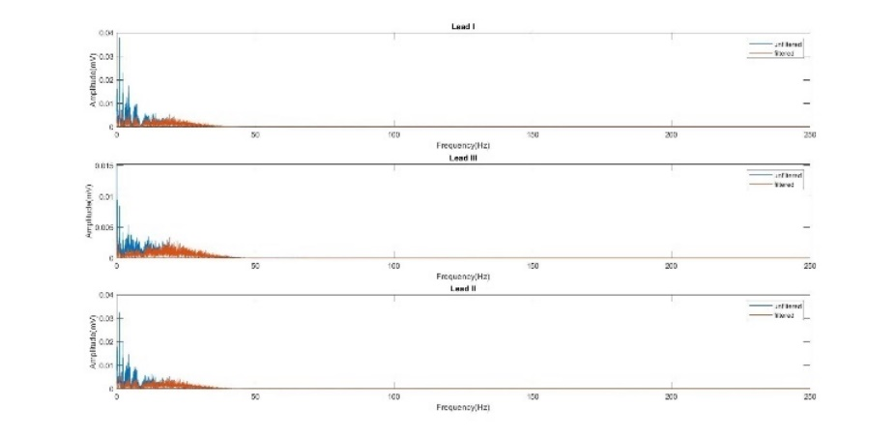

**Figure 7.** ECG signal before and after filtering using FIR 8-50Hz bandpass filter, in frequency domain.

As expected, frequencies between 8-50Hz did not change in amplitude, while amplitude of frequencies under 8 Hz were reduced significantly.

4.1.4 QRS detection:

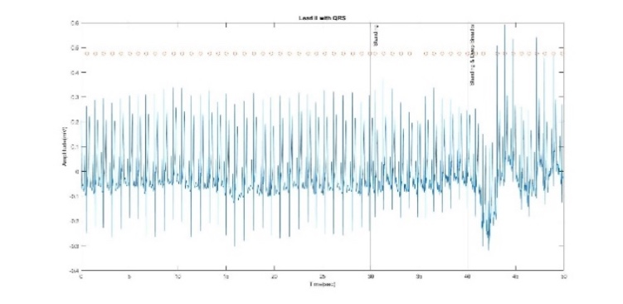As stated, Lead II was chosen to be presented after QRS detection algorithm:

**Figure 8.** ECG signal of Lead II, shown with QRS detected using QRS detection algorithm.

Out of 57 QRS complexes in the signal, 55 were detected. Moreover, the algorithm did not generate any false positives. The QRS that were not detected are both not from the standard sitting position.

4.1.5 HR calculation:

HR calculated to all 3 positions:

**Table 1.** HR values for 3 different positions.

|  |  |  |
| --- | --- | --- |
| Sitting | Standing-Standard Breathing | Standing-Deep Breathing |
| 65.7±3.6[Bpm] | 69.3±2.8[Bpm] | 76.1±14.7[Bpm] |

T-test: H0: Breathing does not affect HR in the same position:

According to two-tailed T-test that was performed using MATLAB, the null hypothesis was not rejected, meaning the difference in HR between heavy breathing and standard breathing in the same position is not substantial. Moreover, P-value=0.191 (P-value>0.05), supporting this claim.

4.1.6 Verifying Einthoven’s law:

**Figure 9.** Computed Lead II, measured Lead II and their subtraction.

**4.2 Part B**

As stated, Lead I was chosen to be processed for HRV and SNR computation. Lead I was chosen as it shown visually all parts of PQRST cycle clearly, and QRS detection algorithm was able to identify all QRS in this Lead’s recording, without any false positives. Lead I was passed through an FIR bandpass filter (8-50Hz), then R-R intervals were determined.

4.2.1 HRV evaluation:

And first 15 HR cycles:

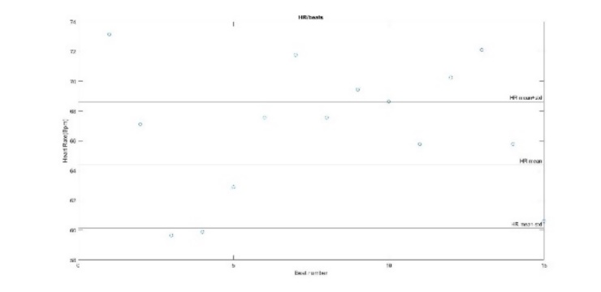

**Figure 10.** HR computation of the first 15 Heart cycles for Lead I

It can be observed that even though most HR cycles are within the limits of the first STD (8/15 beats), a respectful amount in these particular 15 cycles segment falls in the second STD limits (7/15 beats).

The following figure shows a single heartbeat ECG:

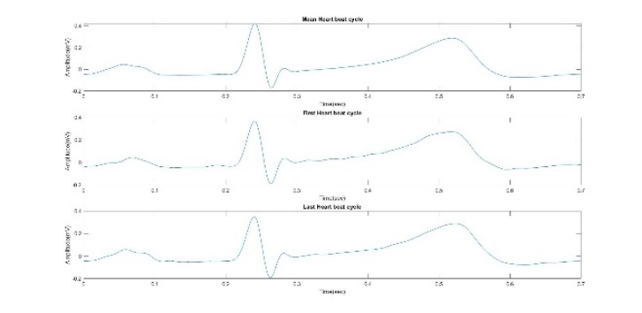

**Figure 11.** Mean ECG signal, first and last beats in the recording.

As expected, all the heart cycles represented are similar in amplitude and general form. No cycles were cut off, as the recording was fairly clean, and all QRS complexes were identified by the QRS detection algorithm.

ST segment of each ECG cycle represented above, between 0.37-0.45 sec (0.08 sec), was defined as representing the isoelectric line. Mean and STD values for the isoelectric line:

**Table 2.** Isoelectric voltage values for a single ECG cycles.

|  |  |
| --- | --- |
| Signal | Isoelectric Voltage(mV) |
| Average cycle | 0.0575±0.0283 |
| First cycle | 0.0763±0.0277 |
| Last cycle | 0.0657±0.0269 |

As can be seen from the table, values are relatively similar for all the signals, while the average cycle has smaller mean value and slightly bigger STD value than the first and last cycles.

4.2.2 SNR computing

As it comes to SNR, it was calculated for both first and average cycles:

As can be seen, the SNR of the average cycle is higher than the SNR of the first cycle.

SNR improvement of both signals:

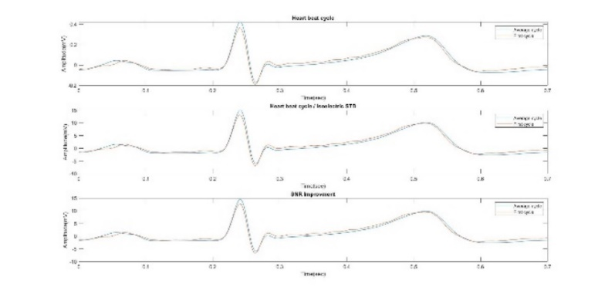

**Figure 12.** SNR improvement of both first and average ECG cycles.

It is noticeable that both signals do not undergo a big morphological difference, but mostly a slight change in amplitude.

**4.3 Part C**

In this part, 23 heart cycles were detected via ECG QRS detection algorithm for the resting period. Although, the last QRS was not used for HS detection, as it was close to the end of the recording, and the window for HS detection was not big enough to be apparent. Therefore, HS were detected for 22 heart cycles. The exact same logic was applied for the active period, but with 11 detected cycles, thus 10 were used. After using HS algorithm, the S1 and S2 that were detected are as followed:

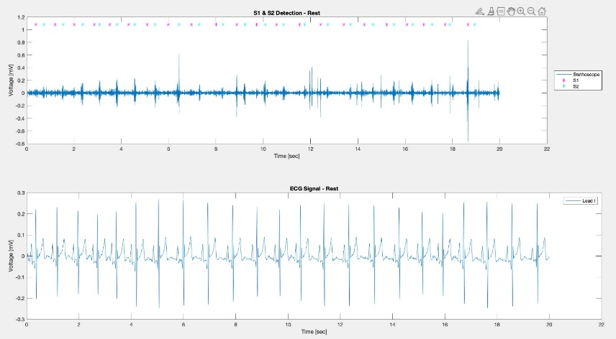

**Figure 13.** ECG and detected HS during resting period.

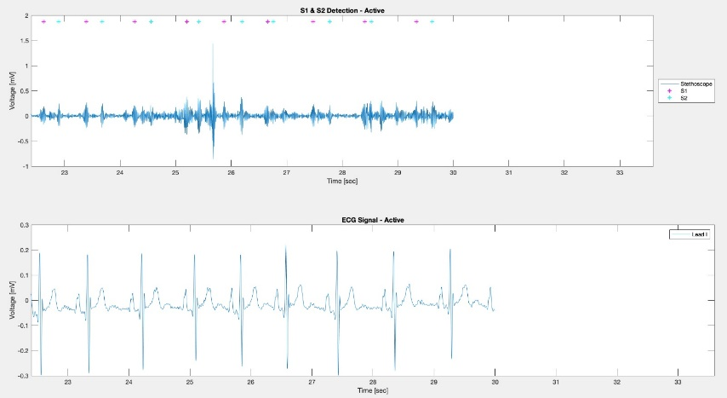

**Figure 14.** ECG and detected HS during active period.

It seems that 44/44 potential heart sounds were detected (S1 and S2 for each QRS candidate). Because the signal in the active period was rather noisy even after filtration, it is hard to tell if the S1 and S2 detected truly represent the real HS and not noises from lungs or movement.

**Table 3.** Changes in intervals for resting and active periods.

|  |  |  |  |
| --- | --- | --- | --- |
| Measurement | Rest | Active | Change between Rest and Active |
| BPM [#/min] |  |  | 8.4% |
| ΔT R-wave to 1st sound [sec] |  |  | -12% |
| ΔT R-wave to 2nd sound [sec] |  |  | -17.9% |
| ΔT 1st to 2nd [sec] |  |  | -19.4% |
| ΔT 2nd sound to next 1st sound [sec] |  |  | 0% |

As can be seen from the table, most values represent the expected outcome- as HR increases, intervals between systole and diastole indications decrease.

5. Discussion______________________

**5.1 Part A:**

In this part of the analysis, the ECG signal was filtered using an FIR bandpass filter between 8-50Hz and was presented both in time and frequency domains. It is easily demonstrated that filtering data is essential in preprocessing the ECG signal. In the time domain, baseline drift influence was negated, isoelectric line was centered around the 0mV line, and overall amplitude of the signal was reduced. In the frequency domain, it is demonstrated by the pre-filtered signal, that a big influence over the signal’s amplitude is found around lower frequencies. Thus, filtering the signal, not letting any influence below 8Hz frequencies to pass through, was significant to the signal’s preprocessing.

Regarding Einthoven’s law, it is highly undoubtable that the law has been confirmed. As it is noticeable, the difference between the computed and measured Lead II is 10-5 mV, thus confirming the signals are practically the same.

The AF2 QRS detection algorithm was able to identify 55/57 of the QRS complexes, resulting in 96.5% sensitivity. Moreover, the algorithm did not generate any false positives.

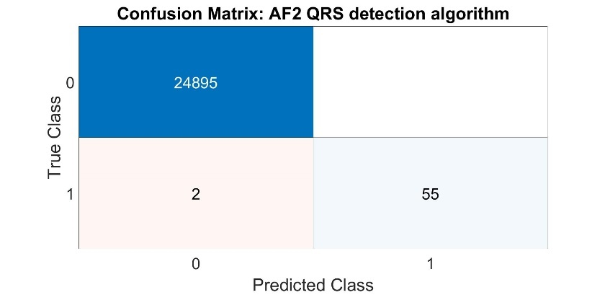

**Figure 15.** Confusion matrix for AF2 QRS detection algorithm

It is noticeable that both QRSs who were not detected by the algorithm were in standing position, breathing regularly and heavily. As stated, AF2 algorithm has difficulties with noises associated with breathing and baseline drift, which both were more apparent in these positions. For that, the FIR bandpass was crucial, but might not be enough to generate 100% sensitivity. Nevertheless, the algorithm did prove itself with the signals in both part B and part C, as it was able to detect all QRSs, and 96.5% sensitivity for part A is very respectful. We believe that the main method to improve its abilities is to furthermore filter noises, and maybe applying a smoothing algorithm, which will be helpful for the derivative computation.

**5.2 Part B:**

Heart rate variability (HRV) is a physiological phenomenon of alteration in the time interval between adjacent heartbeats. It has been shown to be a predictor to some heart diseases, such as myocardium infraction, and emotional arousal, as well as indicating the relations between the parasympathetic and sympathetic nervous system, hence its importance [10]. The HRV is measured as the mean of HR, added with its STD.

The recording for Lead I was not cut, and the HRV was calculated for the whole signal because the algorithm had found all QRS complexes. Hence, any change in the subject’s ECG signal is probably a logical result of the situation. Indeed, the HRV was in a fine range from the previous calculated HR.

SNR is a method comparing the desired signal to the background noises. A ration higher than 1:1 indicates the signal is greater than the noise.

For the graph, 15 first heart cycles HR were taken, and as stated, many of them were found in the second STD range, and higher than the mean. This might indicate that the subject was excited, as the experimenter declared the start of the recording.

As seen in Table 2, mean value of Average cycle was smaller than the other cycles, while STD was bigger. As the isoelectric line in a noise free environment is around the 0 mV line, it is expected that as more cycles will be added the average computation, mean value of the isoelectric line will decrease and go to 0. As for STD, its value is expected to increase, as it depends mean which is subtracted from each value(see equation 15). While the mean is decreases, the difference between the mean and isoelectric values increases, resulting in bigger STD.

A better SNR was received for the average cycle and was 1.14 bigger than SNR for the first cycle. It is expected, as more cycles are added to the average, the lesser the noise’s influence becomes. Having said that, this ECG recording was fairly clean of noises, therefore adding more cycles to the average would not have improved SNR by a significant amount.

A change in the SNR resulting from dividing the R peak by the noise’s STD and the one resulting from dividing the whole mean signal by the noise’s STD was not detected, meaning the noise in the recording was low, even before filtering.

**5.3 Part C:**

In table 1 a difference in the parameters’ values can be seen.

First, an increase in the BPM rate was detected after activity. It can be explained by the increase of oxygen and blood needed by the heart’s myocardium, resulting in the heart pumping faster to fulfill that need.

In addition, all the time differences, R peak to S1, R peak to S2 and S1 to S2, calculated after activity were shorter then calculated at rest. All these parameters are immediately affected by the heart rate, as the heart cycle is shortened, therefor the results match our expectations.

The last parameter, time difference between S2 to the next S1, hadn’t shown a different value before and after activity. This result may indicate that the changes in the subject’s HR are mostly expressed inside one heart cycle, probably by the strength of the systole, and not in between cycles. A reasonable explanation for this result is the subject’s athlete abilities.

Along the whole recording we encountered adequacy between the HS detection and the ECG signal. It is possible to not have an overlap between the HS and the ECG incase a noise got in the recording, caused by high intensity activity resulting in ventricular contraction before fully diastole, by breathing or by stethoscope movement.

HS detection algorithm was able to find the highest energy values in the HS recording, respectively to the R peaks in the ECG value, allegedly representing S1 and S2. It is hard to identify whether these peaks correctly represent the HS or mistaken by noises, as the filtered signal is still not ideal. The algorithm had found all the heart sounds in the recording, comparing to the number of R peaks. thus, we can say the algorithm sensitivity is 100%.

Possible error factors in the algorithm are noises passing through the filter and being identified as HS, choosing a thresh value that is too high and misses weaker heart sounds.

The algorithm can be improved by changing it filter to one that can isolate a smaller range of frequencies, in order to eliminate more noises, or choosing a different thresh value.

**5.4 Conclusions regarding the experiment’s objectives:**

As stated before, one of the experiment’s main objectives was processing and understanding ECG in three different positions: sitting, standing, and standing while taking deep breaths. We applied filters and QRS detection algorithms, calculated heart rates for all those recording, therefore, it can be said confidently that the objective was obtained.

Another objective was confirming Einthoven’s law. After showing the difference between the computed and measured Lead II (figure 9), and showing that the difference is insignificant, it can be said that the objective was obtained as well.

Regarding more measurable objectives: QRS complexes were detected with very high sensitivity, R-R intervals, HR, HRV and SNR were computed precisely, and gave an accurate and interesting view about myocardial electrophysiology.

Detecting the S1 and S2 heart sounds was more of a challenge than the rest of the tasks in this experiment. Despite that, each heart sound was detected in reference to each QRS wave, and relevant intervals were successfully computed.

In conclusion, all the experiment’s objectives were achieved, therefore the experiment can be crowned as a success.

6. References_____________________

6.1 Bibliography:

1. Pflanzer R (2013) Physiology Lessons for use with the Biopac Student Lab.
2. [L G. Tereshchenko](https://www.ncbi.nlm.nih.gov/pubmed/?term=Tereshchenko%20LG%5BAuthor%5D&cauthor=true&cauthor_uid=26364232), and [Mark E. Josephson](https://www.ncbi.nlm.nih.gov/pubmed/?term=Josephson%20ME%5BAuthor%5D&cauthor=true&cauthor_uid=26364232)(2016). Frequency and content characteristics for Ventricular Conduction. Journal of Electrocardiology.
3. [S. Chatterjee](https://ietresearch.onlinelibrary.wiley.com/action/doSearch?ContribAuthorRaw=Chatterjee%2C+Shubhojeet), [R. S. Thakur](https://ietresearch.onlinelibrary.wiley.com/action/doSearch?ContribAuthorRaw=Thakur%2C+Rini+Smita), [R. N. Yadav](https://ietresearch.onlinelibrary.wiley.com/action/doSearch?ContribAuthorRaw=Yadav%2C+Ram+Narayan), [L. Gupta](https://ietresearch.onlinelibrary.wiley.com/action/doSearch?ContribAuthorRaw=Gupta%2C+Lalita), [D. K. Raghuvanshi](https://ietresearch.onlinelibrary.wiley.com/action/doSearch?ContribAuthorRaw=Raghuvanshi%2C+Deepak+Kumar)(2020). Review of noise removal techniques in ECG signals. IET Signal Processing.
4. E. A. Ashley, J. Niebauer(2004). Cardiology explained.‏
5. Friesen, G. M., Jannett, T. C., Jadallah, M. A., Yates, S. L., Quint, S. R., & Nagle, H. T. (1990). A comparison of the noise sensitivity of nine QRS detection algorithms. IEEE Transactions on biomedical engineering
6. Wang, X., Li, Y., Sun, C., & Liu, C. (2009, October). Detection of the first and second heart sound using heart sound energy. In 2009 2nd International Conference on Biomedical Engineering and Informatics. IEEE.‏
7. M. El-Segaier, O. Lilja, S. Lukkarinen, L. Sornmo, R. Sepponen, E. Pesonen(July 2005). Computer-Based Detection and analysis of Heart Sounds and Murmurs. Annals of Biomedical Engineering.
8. V. Gross, A. Dittmar, T. Penzel, F. Schuttler, P. von Wichert(1999). The relationship between Normal lungs sounds, age and gender. ATS Journals.
9. R. Pal(2017). Comparison of the design of FIR and IIR filters for a given specification and removal of phase distortion from IIR filters. IEEE.
10. F. Shaffer, J.P. Ginsberg (2017). An overview of heart rate variability metrics and norms. Frontiers in Public Health

6.2 BIOPAC screenshots:

**Figure 16.** Signal used in Part A.

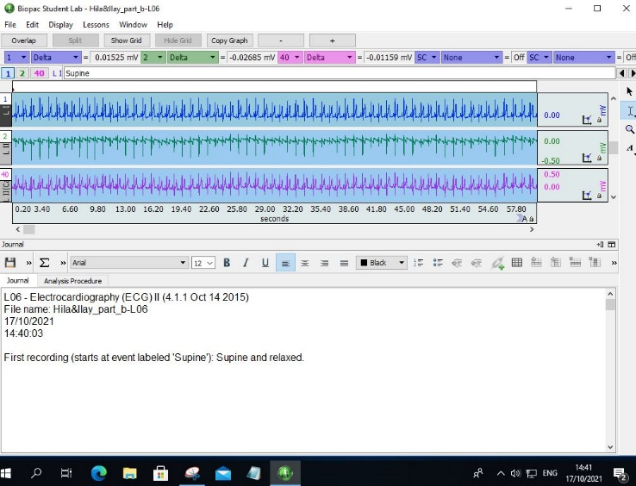

**Figure 17.** Signal used in Part B.

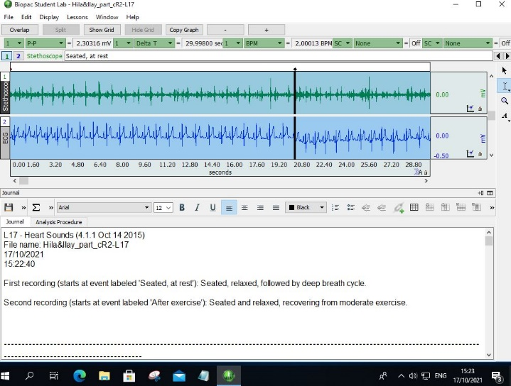

**Figure 18.** Signal used in Part C.